

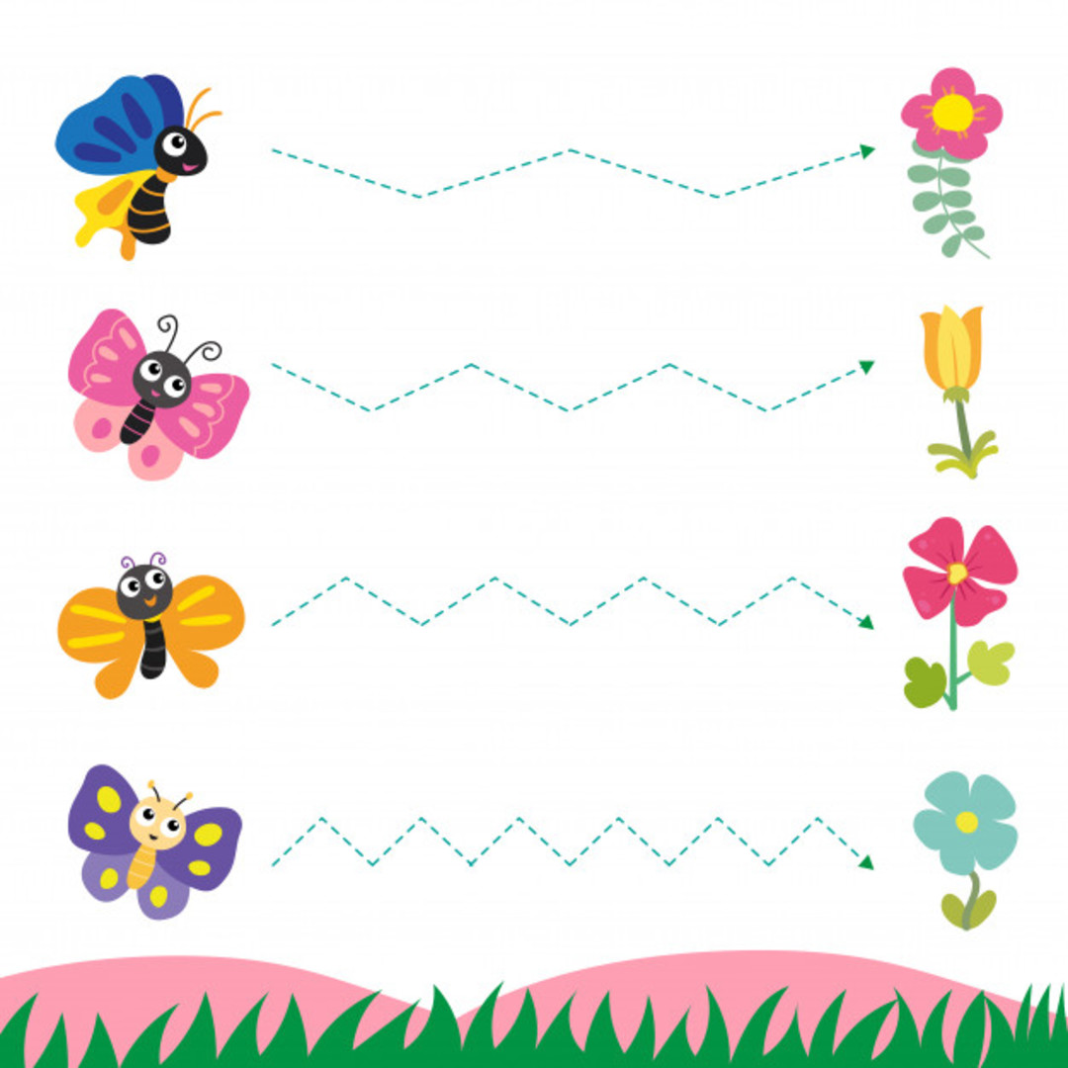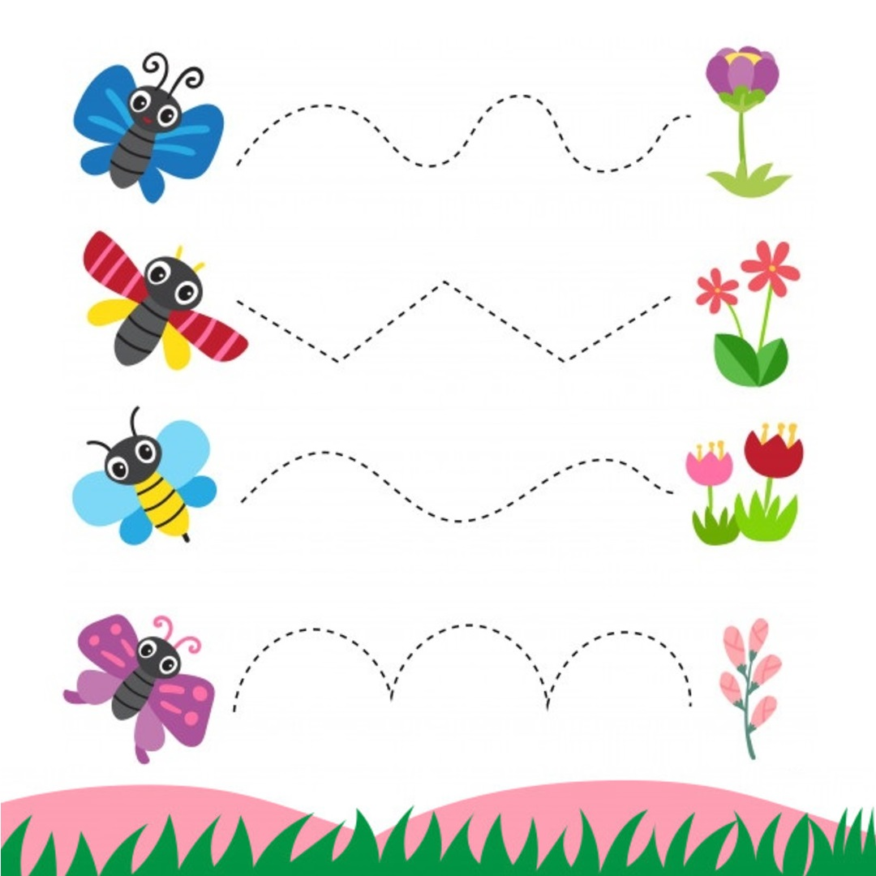





Dokresli barančekovi vlnu:



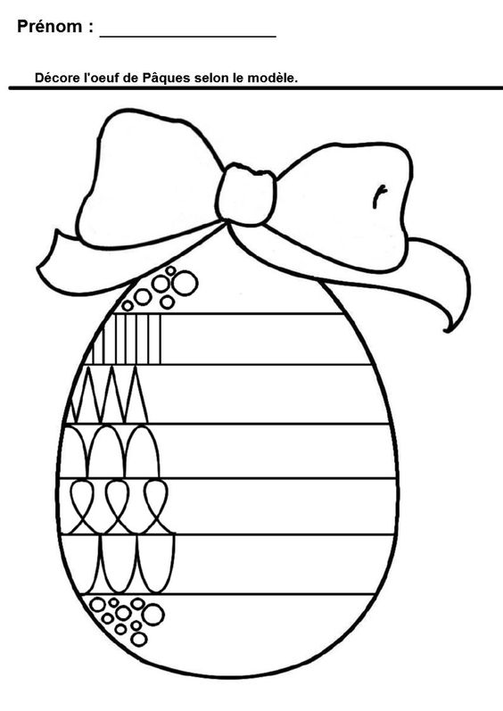

Zdroje:

[https://bit.ly/2UuRtIN](https://l.facebook.com/l.php?u=https%3A%2F%2Fbit.ly%2F2UuRtIN%3Ffbclid%3DIwAR2kusx2uCGPdNX0xQgOUqpUjqlIFXzqS0FBsYUYLvK8qxMmvM08kULYqMc&h=AT3URrmxEiy-RuFY06njapwzy3lknFaR20SaZTHWboBR-K9JiixMLBQ0ZSBLWBGrFQ1OG1n_I8Rz6az4WPx0EWeIJLIXRZtNpSgFjMM3dV8BaZ813Oaek8NKJ2KnyikDXnyEhCELmfVhYk37TnyL2__tpB_znz8PXpAztg3oLlv_vHUZcQXBIzARJCjzviV-jr2LP77_zE855r57Rv80bVU6PyCuI9FHkfmLzlV5_6DYjC2wF5RtXlIC92jnkZUl3x2lvJOlO739AKDUN2i44qI5n3tGSw_2SmVM1mWcgW7GZfdgQd5NLPs4K0Aie-Z9hLYBSGfLVQ5PgCobPtRyffVqvsDHeBAEV3KOfVVqH7wipmlmFx3YWOE2j3WWhChEJKkxklNaXb7ZNNWnc1icvH1UqGzDn03crmLm0G0Id1IrGetDJK3WXY7T80a_JemYdncFFg6tOc-eRet5jYD01_eGVtmD8r4PwfDnpEgKGZSK_rcDRQclwh4KZSpvlPJsC76Pqnbu1Eh2XcQIjkfy0fKD7tFPAOBHej2UHZuFmHKO_x7U3lCKzEmXDmZ6Vk4fOQcmbfTYApQWsYDYI9lGydNQbcNGH4e1WVShLwziQcE0uwhJany7Y6sM59XkdZ_vGo4-HD9kRKvLwHixCOZX8zeVp9X5FJc7Rmj4KHzmTwIs_c5x8TuKMT_AuHwUYvZCcaUWGXKHOGyOsAmHzLVUMbi2JqD4-ej2Jw8kjKdUuILbcbyC2ilXC_T6Q3sltVtgNytGdbIuykhXaqtlzpsYcR59iTlBtxuk2yR8eQtsDTgabuuMJFuk1hvpJn353fgh41QfwTTTUchVAKGFJ4bilp2-8LbJZYKeH9j_YVS0OgyB8hY4Y4XeMOoyvRU-)

<https://sk.pinterest.com/>